Food safety program

Business name:

Name of proprietor:

Address:

Phone:

Email:

Licence No.:

Date:

Contents
Using this guide 1
Part 1: Company overview 2
Business overview and scope of food safety program 2
Organisation chart 3
Company commitment 4
Part 2: HACCP plan 5
HACCP team 5
Product description and intended use 6
Process flow chart 7
Hazard analysis 8
Hazard audit table 9
Verification procedures 10
Documentation and record keeping 11
Part 3: Pre-requisite programs 12
Pre-requisite program: 13
Appendix 1: Codex decision tree 15
Appendix 2: Checklist 16

Using this guide
A food safety program (FSP) consists of documents that systematically identify food safety hazards and describe activities that ensure the safety of a dairy food is controlled during manufacturing, processing, packing, and storage.
This model FSP enables dairy manufacturers to develop and record how they intend to manage the safety of their manufacturing operations. The FSP must be signed and dated by the owner or operator of the manufacturing facility when it is first completed and whenever the plan is modified.
Using this model may be a quicker, simpler and more cost-effective way to develop and document your system, rather than employing someone to write your food safety program.
This model food safety program has been drafted in Microsoft Word and can be used, amended, or modified as you see fit.
Blank spaces indicate where text needs to be added, and the yellow call-out boxes (see example below) provide guidance and direction on what is required in each section.

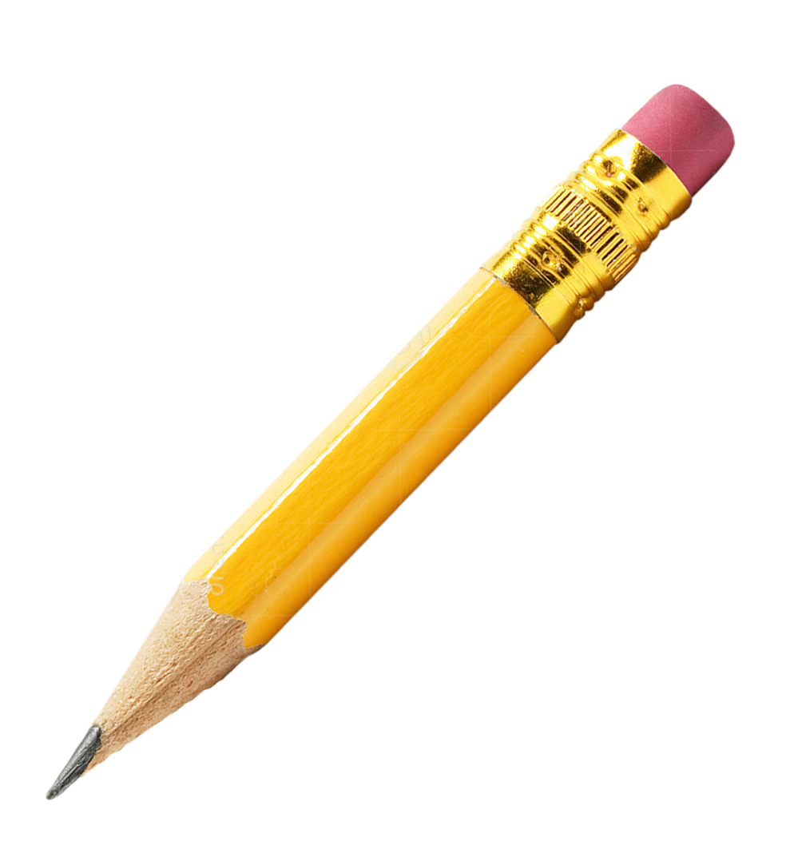
EXAMPLE
Guidance and direction:
Prepare a brief introduction describing your dairy business.

Where appropriate there will be a reference to the relevant Part of Developing a food safety program.



For guidance on what is required in each section of this document, refer to the notes and advice contained in the companion publication: Developing a food safety program (DFSV, 2017).
As you work through the task of developing your FSP, use the Checklist (Appendix 2) to break each step into specific tasks and keep organised – tick off each task as it is completed to avoid missing the inclusion of vital information.

Part 1: Company overview
Guidance and direction:
Prepare a brief introduction describing the nature of your business i.e. an overview of operations and how you intend to meet regulatory requirements.
Include a statement of company commitment to the FSP and to the manufacture of safe and suitable food.

See Part 1 of Developing a food safety program.

Business overview and scope of food safety program
Description of business

List of products

Food safety objectives

Scope of your food safety program

Organisation chart
Place text here…

Company commitment
Place text here…

Part 2: HACCP plan

HACCP team
Guidance and direction:
Record details of the team responsible for creating and maintaining your food safety program – including those involved in ongoing analysis/review and improving procedures to manage food safety risks.

See Part 2, Step 1 of Developing a food safety program.

Team | Name | Position/skill set
Team leader
Member
Member
Member
Member

Product description and intended use
Guidance and direction:
Describe each dairy food product – listing ingredients, composition, physicochemical properties, and intended use.
Include information on special handling or preparation and whether the food will be eaten by at-risk consumers.
This information will assist in identifying hazards associated with your products.

See Part 2, Steps 2 and 3 of Developing a food safety program.

Product name
Ingredients
Composition
(Fat, moisture, protein, salt concentration)
Physicochemical properties
(pH, Aw, Redox potential)
Processing overview
Method of preservation
(heat, freezing, chilling, acidification, concentration, drying, smoking)
Allergen advice
Packaging
Storage conditions
Shelf life
Distribution
Intended use
Condition before consumption
Consumers

Process flow chart
Guidance and direction:
Provide process flow charts to provide a clear and uncomplicated, description of the main steps in producing each dairy food.
Include inputs into the process such as ingredients, food additives, and packaging.

See Part 2, Steps 4 and 5 of Developing a food safety program.

Symbols
OPERATION 1
(provide details)
Activity

Process flow direction

Hazard analysis

Rank hazards
Guidance and direction:
Perform a hazard analysis for each product.
Identify individual microbiological, physical, and chemical hazards (including allergens).

See Part 2, Step 6 of Developing
a food safety program.

Hazard categories | Hazard/process step | Likelihood | Consequence | Risk ranking
Microbiological hazards
Chemical hazards
Physical hazards

Identify critical control points
Guidance and direction:
When completing this table, use the Codex decision tree (Appendix 1).
It is also important to consider the severity and likelihood of each hazard.

See Part 2, Step 7 of Developing a food safety program.

Process step | Hazard | Control measure | Q1 | Q2 | Q3 | Q4 | Q5 | CCP

CCP = Critical control point

Hazard audit table
Guidance and direction:
This is where you describe how each CCP will be monitored, listing the critical limits, corrective action, and the recording of monitoring activity.

See Part 2, Steps 8, 9 and 10 of Developing a food safety program.

Process step | Hazard | Control measure | Critical limits | Monitoring | Corrective action | Records
What:
How:
When:
Who:
What:
How:
When:
Who:
What:
How:
When:
Who:
What:
How:
When:
Who:
What:
How:
When:
Who:

Verification procedures
Guidance and direction:
Describe how you verify your HACCP plan to ensure it is working as designed.
This will include sampling and analysis of finished products, audits of your HACCP system, audits of records, and a review of deviations/non-conforming products.

See Part 2, Step 11 of Developing a food safety program.

Place text here ….

Documentation and record keeping
Guidance and direction:
Efficient and accurate record keeping is essential.
Records should be kept of monitoring, corrective actions, root cause analysis and modifications to the HACCP plan.
Under the Food Standards Code, you are required to retain copies of all written reports of audits of the food safety program conducted by a food safety auditor within the last four years.
See Part 2, Step 12 of Developing a food safety program.

Part 3: Pre-requisite programs
Guidance and direction:
List and provide a description of all the pre-requisite programs that underpin the way you manage food safety.
This will include both policies and all your procedures, work instructions, and standard operating procedures.

See Part 3 of Developing a food safety program and Appendices 2 and 3 for examples of PRPs.

- Raw material receival
- Pest control
- Cleaning and sanitation
- Good manufacturing practice
- Staff training
- Recalls and traceability
- Personal hygiene
- Management review/Internal audit
- Allergen management
- Calibration
- Document and record control
- Preventative maintenance
- Foreign matter and prevention of contamination

You may also require other pre-requisite programs and/or procedures including corrective and preventative action, non-conforming product, sampling and testing, product labelling, and water and waste handling and management.

Pre-requisite program:

Purpose

Scope

Definitions

Methodology

Monitoring
Who | What | How | When | Record

Corrective action

Responsibilities

Records
Title | Document No.
* Records retained for 4 years

Work instructions
Document Title | Document No.

Verification

References

Appendix 1: Codex decision tree

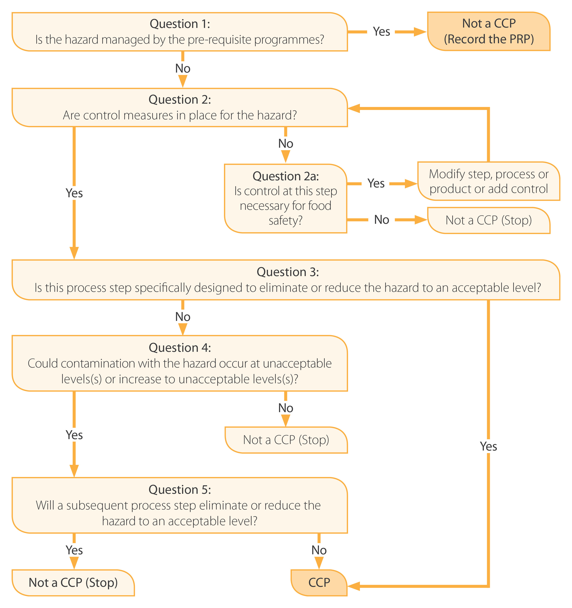

Appendix 2: Checklist
This checklist is to assist you to complete the documentation of your food safety program.
Component | Activity and notes | Completed (YES/NO)
Company overview
Description | - Describe business  - Statement of company commitment
Scope and organisation chart | - What will be covered by your FSP  - Organisation chart
HACCP plan
HACCP Team | - Team established  - Members identified
Product description and  intended use | - Description of each food product – ingredients, composition, properties, and intended use  - Identify any special handling requirements
Process flow chart | - Depiction of all steps in manufacture of every dairy food (include inputs)
Hazard analysis | - Complete the hazard analysis table for identified hazards at each processing step
Hazard audit table | - Control measures for hazards identified  - Critical limits established  - Monitoring requirements identified  - Corrective action described
Verification | - Description of how you verify your HACCP plan
Record keeping | - Describe retention of all relevant documents under your HACCP plan
Prerequisite programs | Preparation of PRP including standard operating procedures and work instruction
 | Raw material receival
 | Pest control
 | Cleaning and sanitation
 | Good manufacturing practice
 | Staff training
 | Recalls and traceability
 | Personal hygiene
 | Management review/Internal audit
 | Allergen management
 | Calibration
 | Document and record control
 | Preventative maintenance
 | Foreign matter/prevention of contamination

Once completed you are now ready to submit to Dairy Food Safety Victoria.

